***Validation***

***Index.html:***

***Blog.html:  
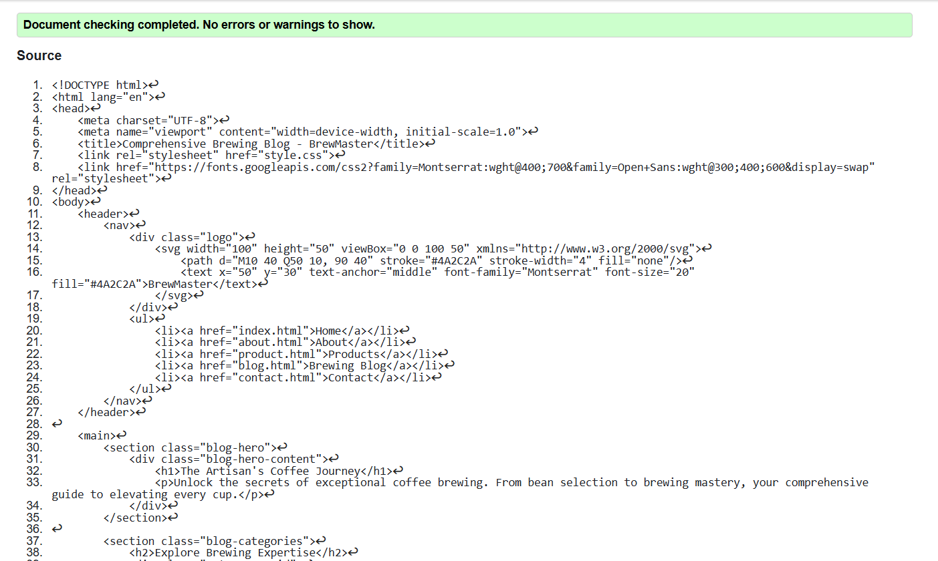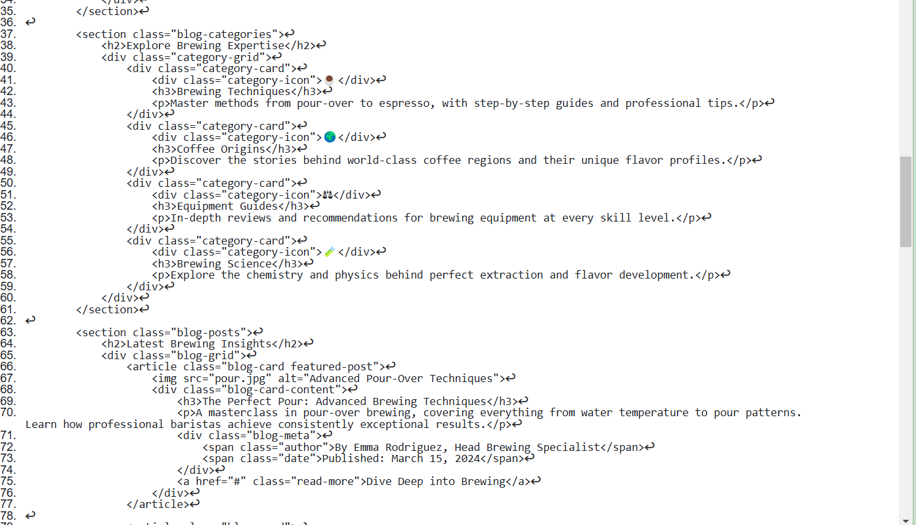***

***About.html:***

***Product.html:  
***

***Contact.html:  
***

***Style.css:  
  
style1.css:  
  
style2.css:  
style3.css:  
  
  
Wireframe:  
